
VIVEKANANDA INSTITUTE OF PROFESSIONAL STUDIES - TECHNICAL CAMPUS
Grade A++ Accredited Institution by NAAC
NBA Accredited for MCA Programme; Recognized under Section 2(f) by UGC;
Affiliated to GGSIP University, Delhi; Recognized by Bar Council of India and AICTE
An ISO 9001:2015 Certified Institution

SCHOOL OF ENGINEERING & TECHNOLOGY

B. Tech Programme: AI-ML (A)
(5th Semester)

Course Title: Design and Analysis of Algorithms Lab

Course Code: AIML- 353

Submitted To: Submitted By:
Dr. Sandhya Tarwani Name: Kunsh Sabharwal
Enrolment No: 01117711623
VIVEKANANDA INSTITUTE OF PROFESSIONAL STUDIES - TECHNICAL CAMPUS
Grade A++ Accredited Institution by NAAC
NBA Accredited for MCA Programme; Recognized under Section 2(f) by UGC;
Affiliated to GGSIP University, Delhi; Recognized by Bar Council of India and AICTE
An ISO 9001:2015 Certified Institution
SCHOOL OF ENGINEERING & TECHNOLOGY

VISION OF INSTITUTE

To be an educational institute that empowers the field of engineering to build a sustainable future by providing quality education with innovative practices that supports people, planet and profit.

MISSION OF INSTITUTE

To groom the future engineers by providing value-based education and awakening students' curiosity, nurturing creativity and building
capabilities to enable them to make significant contributions to the world.

VIVEKANANDA INSTITUTE OF PROFESSIONAL STUDIES - TECHNICAL CAMPUS
Grade A++ Accredited Institution by NAAC
NBA Accredited for MCA Programme; Recognized under Section 2(f) by UGC;
Affiliated to GGSIP University, Delhi; Recognized by Bar Council of India and AICTE
An ISO 9001:2015 Certified Institution
SCHOOL OF ENGINEERING & TECHNOLOGY
INDEX
S.No. | Experiment | Date | Marks |  |  | Remarks | Updated Marks | Faculty Signature
S.No. | Experiment | Date | Laboratory Assessment (15 Marks) | Class Participation (5 Marks) | Viva (5 Marks)
1.
2.
3.
4.
5.
EXPERIMENT 1

Problem statement: Sort a given set of elements using insertion sort algorithm and find the time complexity.
Theory:

Algorithm:

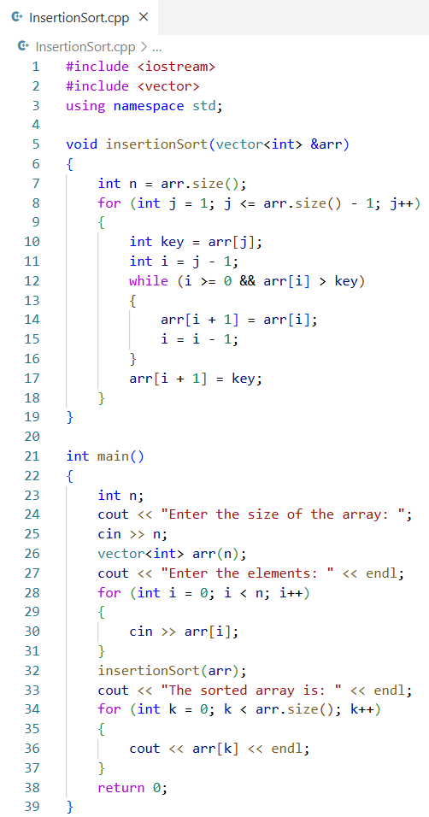
Source Code:
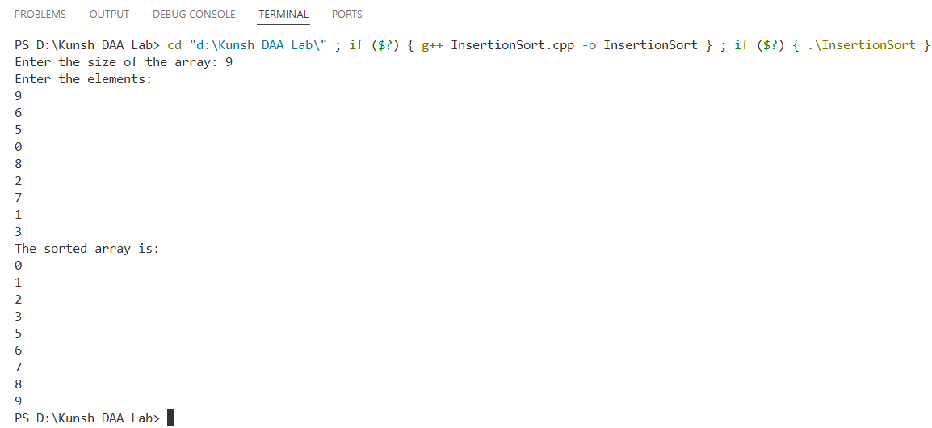
Output:
Time Complexity:
 | Best | Worst | Average
Insertion Sort

Learning Outcome:

EXPERIMENT 2

Problem statement: Sort a given set of elements using selection and bubble sort algorithms and find the time complexity.
Theory:
(a) Selection Sort -

(b) Bubble Sort –

Algorithm:
(a) Selection Sort –

(b) Bubble Sort

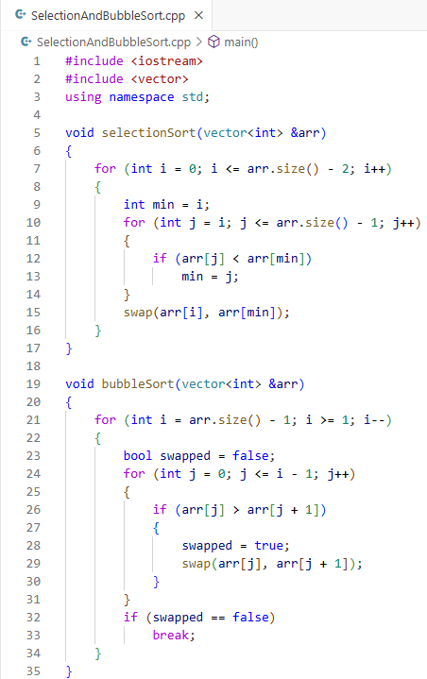
Source Code:

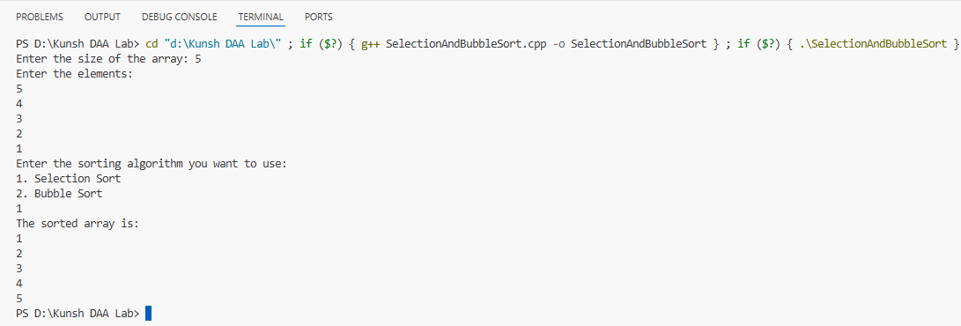
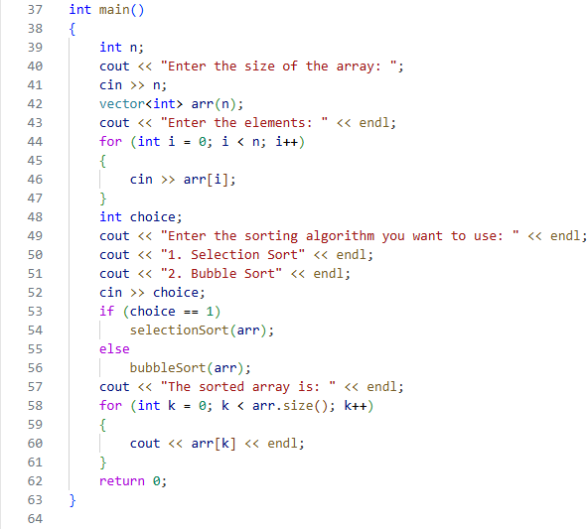
Output:
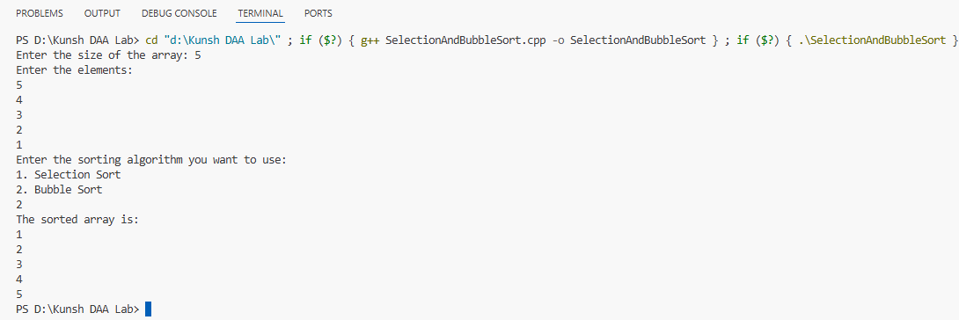
Time Complexity:

 | Best | Worst | Average
Selection Sort
Bubble Sort

Learning Outcome:

EXPERIMENT 3

Problem statement: Apply linear search and binary search algorithms to find an element in a given set of data and analyse their time complexity.
Theory:

Algorithm: (a) Linear Search

- Binary Search

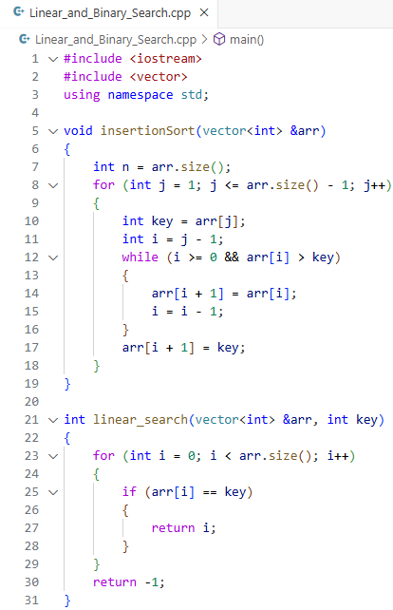
Source Code:

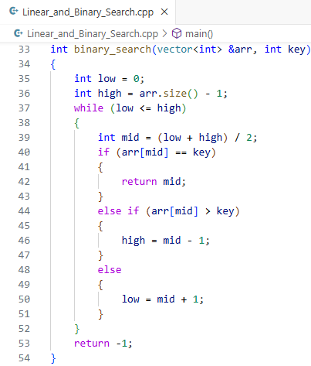

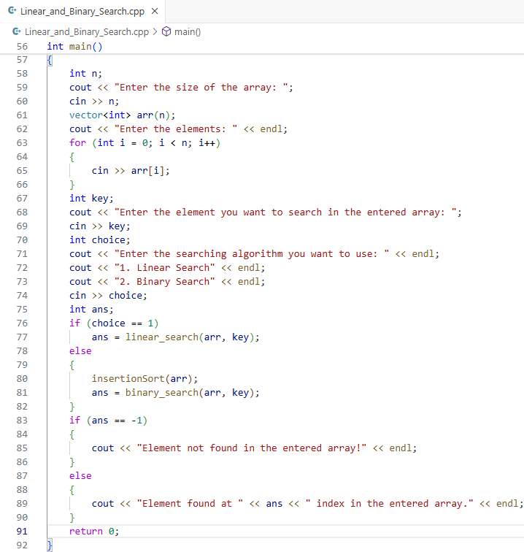
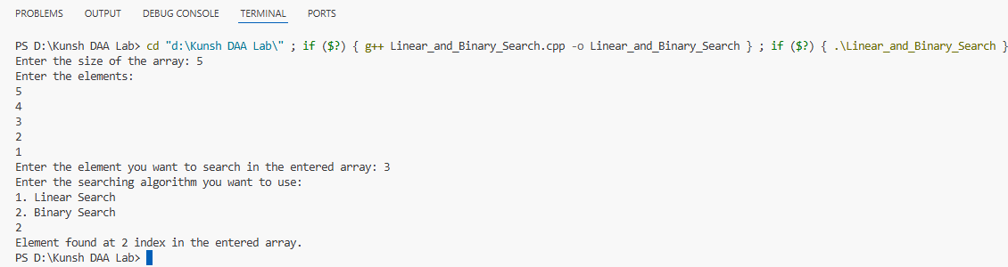
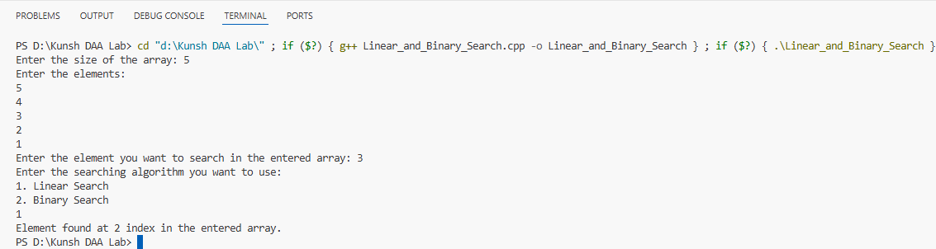
Outputs:
Time Complexity:

 | Best | Worst | Average
Linear Search
Binary Search

Learning Outcome:

EXPERIMENT 4

Problem statement: Sort a given set of elements using merge sort algorithm and find the time complexity for different values of n.
Theory:

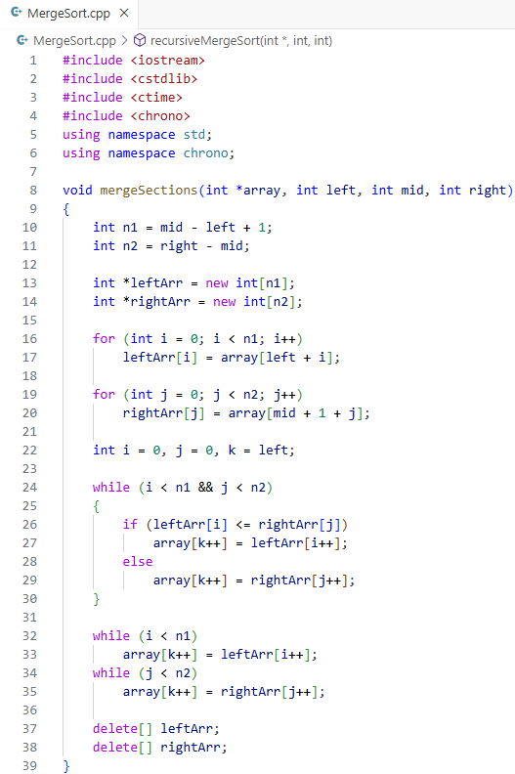
Source Code:
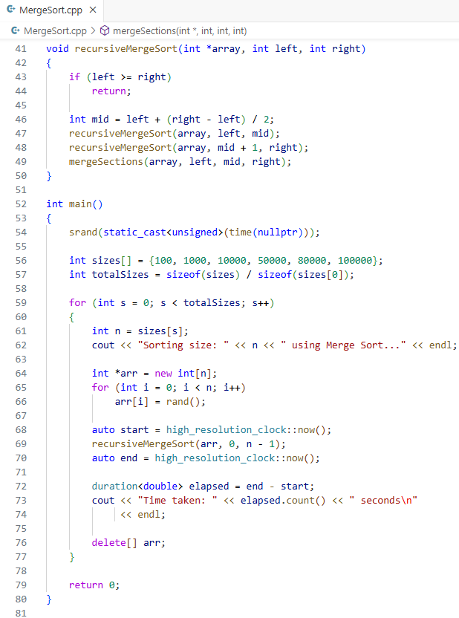
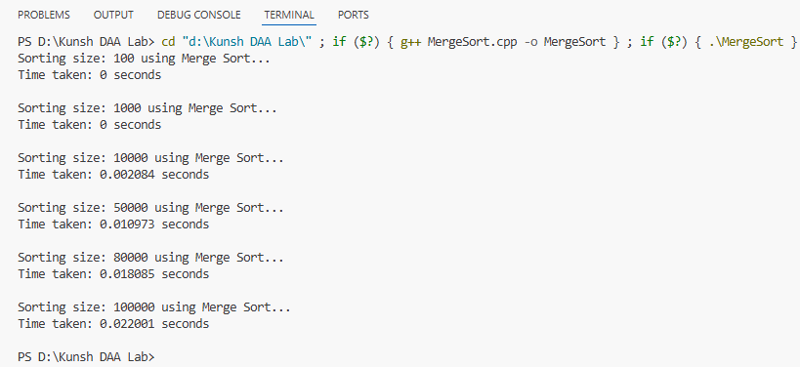
Output:
Input (n) vs Time (t) Table:
N | Time (t) in secs
100 | 0
1000 | 0
10000 | 0.002999
50000 | 0.012087
80000 | 0.019073
100000 | 0.022076
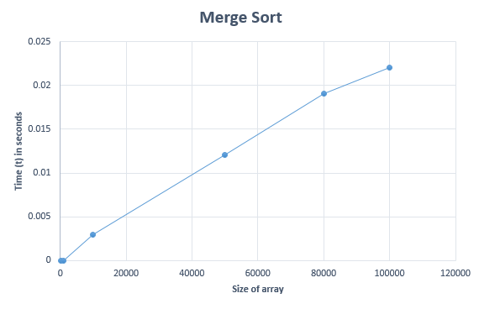
Graph:

Time Complexity:
 | Best | Worst | Average
Merge Sort

Learning Outcome:

EXPERIMENT 5

Problem statement: Sort a given set of elements using quick sort algorithm and find the time complexity for different values of n.
Theory:

Algorithm:

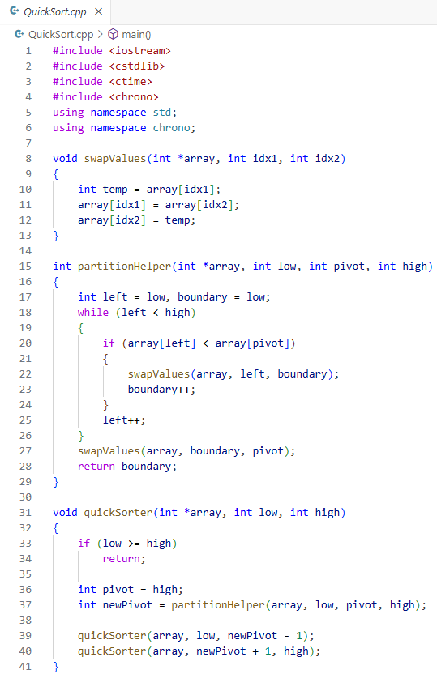
Source Code:
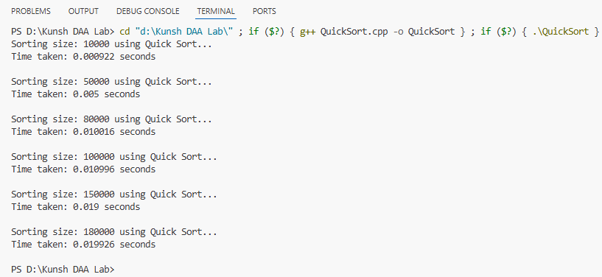
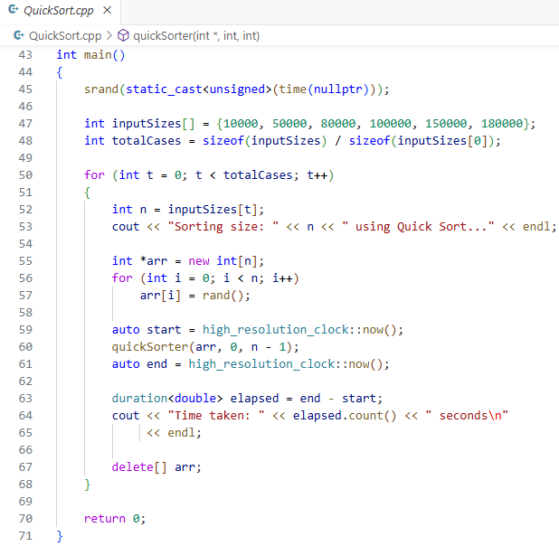
Output:
Input (n) vs Time (t) Table:
N | Time (t) in secs
100 | 0.000922
1000 | 0.005
10000 | 0.010016
50000 | 0.010996
80000 | 0.019
100000 | 0.019926
Graph:
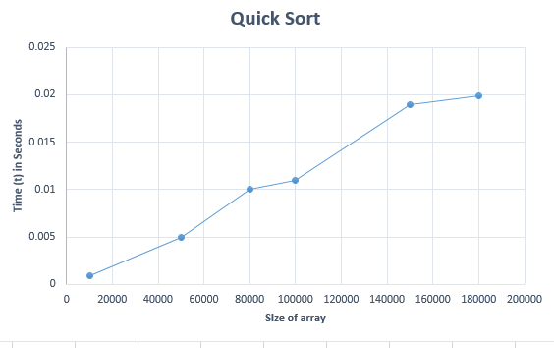

Time Complexity:
 | Best | Worst | Average
Quick Sort

Learning Outcome:

EXPERIMENT 6

Problem statement: Write a program to implement Fractional Knapsack Problem using Greedy Method.
Theory:

Algorithm:

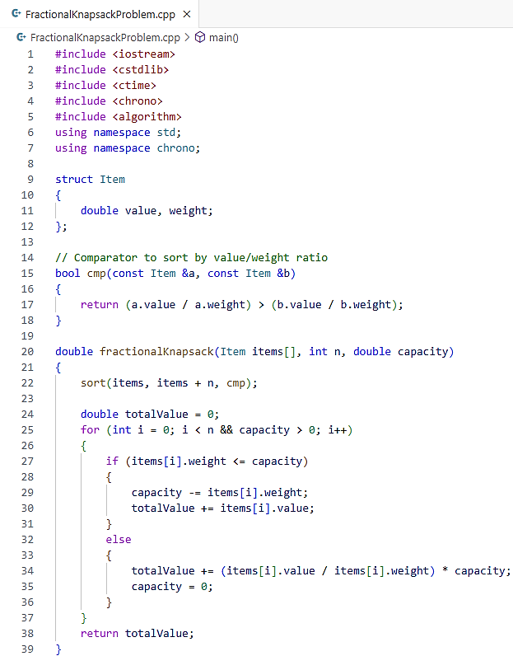
Source Code:
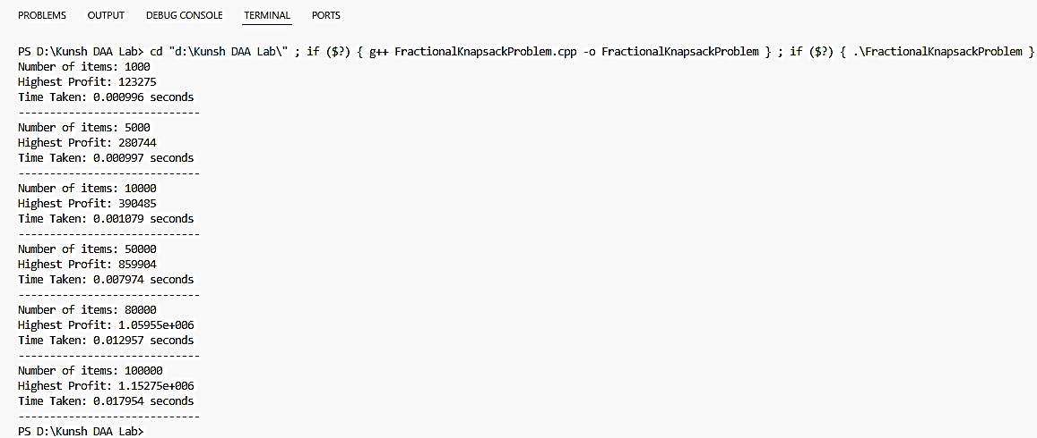
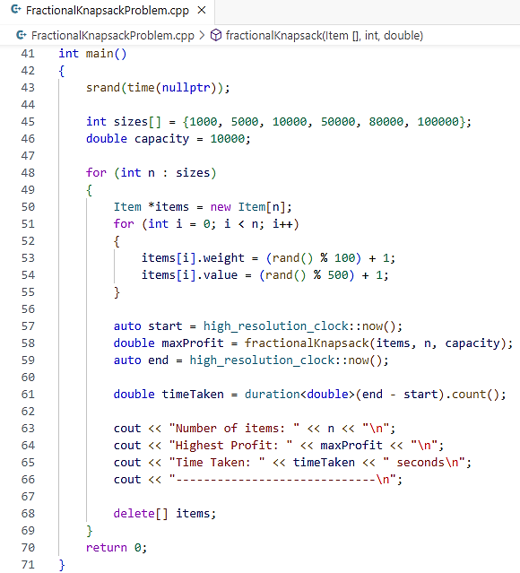
Output:
Input (n) vs Time (t) Table:
Maximum Profit from Knapsack | Time (t) in seconds
123275 | 0.000996
280744 | 0.000997
390485 | 0.001079
859904 | 0.007974
1.06E+06 | 0.012957
1.15E+06 | 0.017954
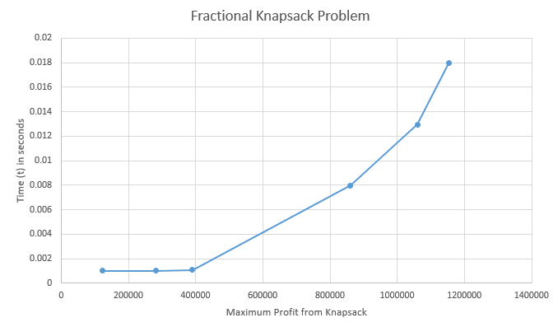
Graph:
Time Complexity:
 | Best | Worst | Average
Fractional Knapsack

Learning Outcome:

EXPERIMENT 7

Problem statement: Write a program to find minimum spanning tree using Prim's Algorithm.
Theory:

Algorithm:

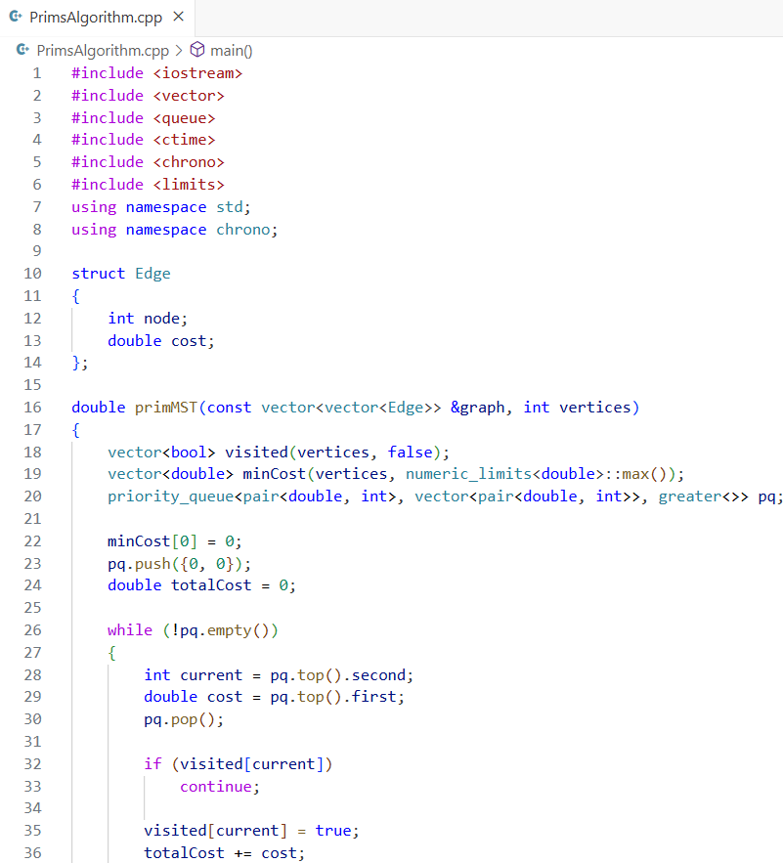
Source Code:
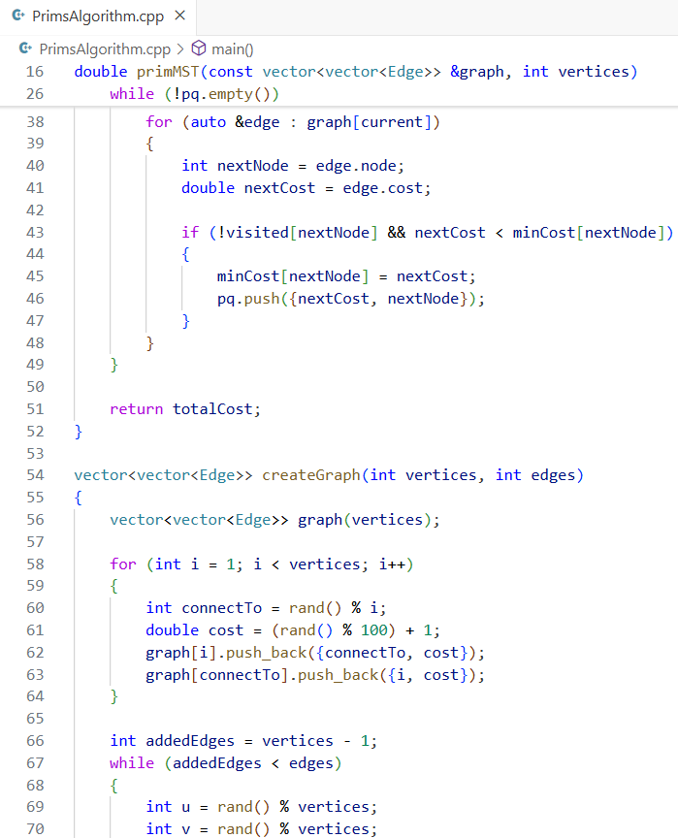
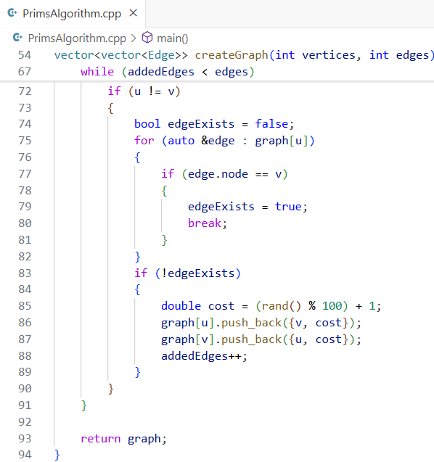
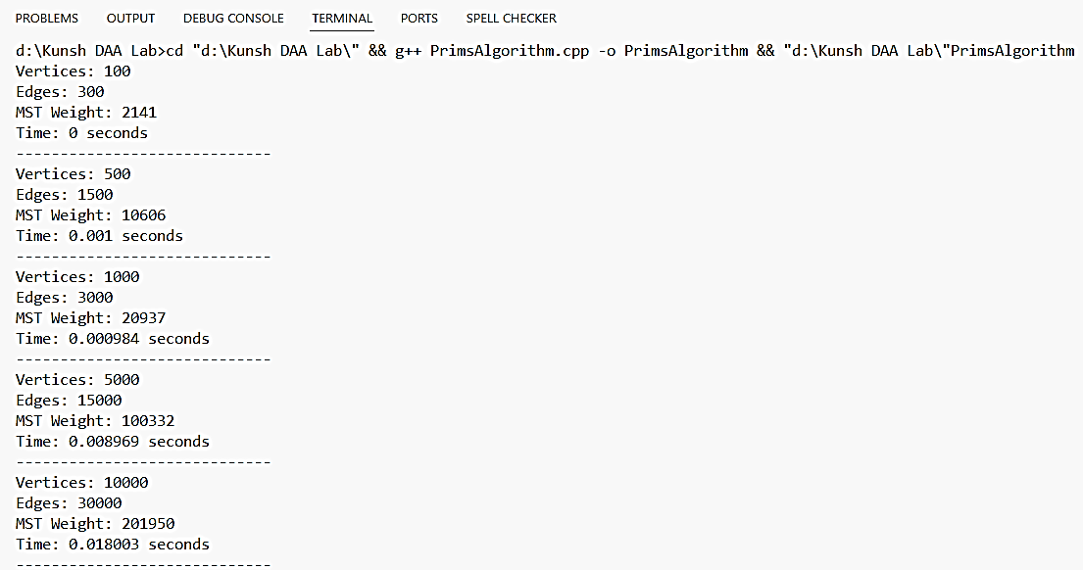
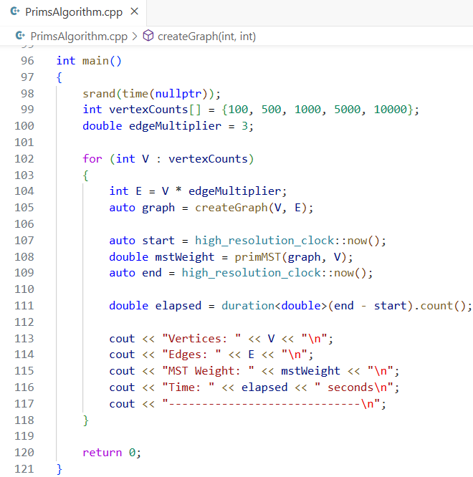
Output:
Input (n) vs Time (t) Table:
Number of Nodes | Time (t) in seconds
100 | 0
500 | 0.001
1000 | 0.000984
5000 | 0.008969
10000 | 0.018003
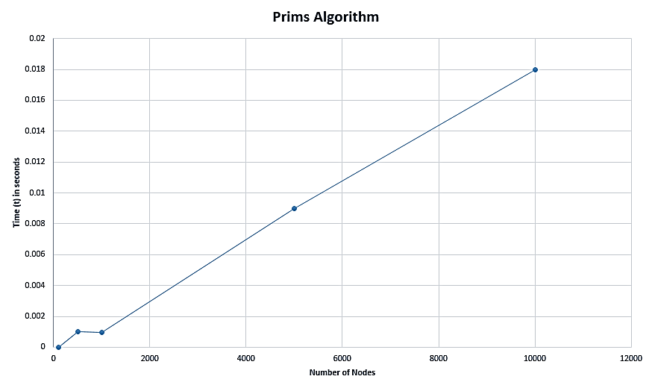
Graph:
Time Complexity:
 | Best | Worst | Average
Prims Algorithm

Learning Outcome:

EXPERIMENT 8

Problem statement: Write a program to find minimum spanning tree using Kruskal’s Algorithm.
Theory:

Algorithm:

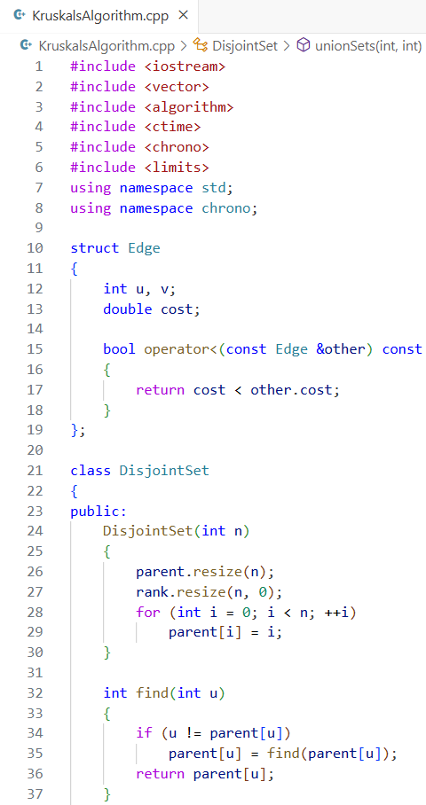
Source Code:
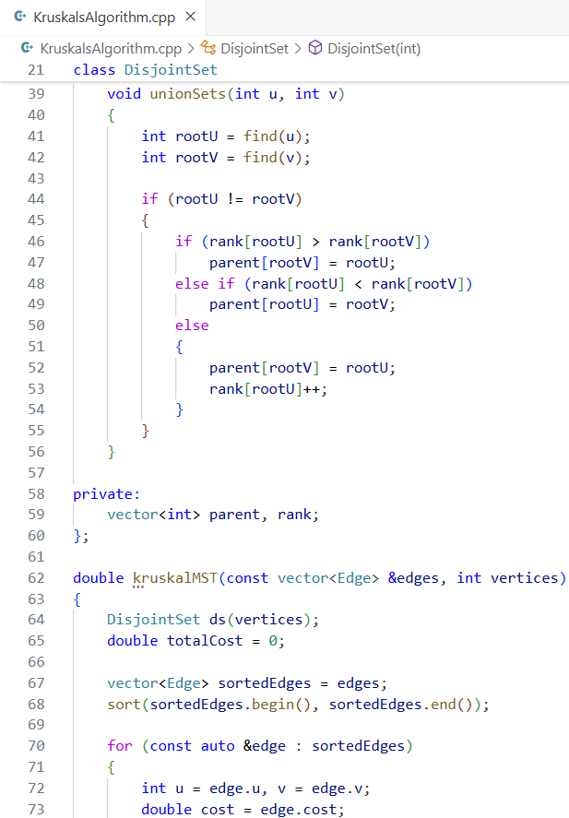
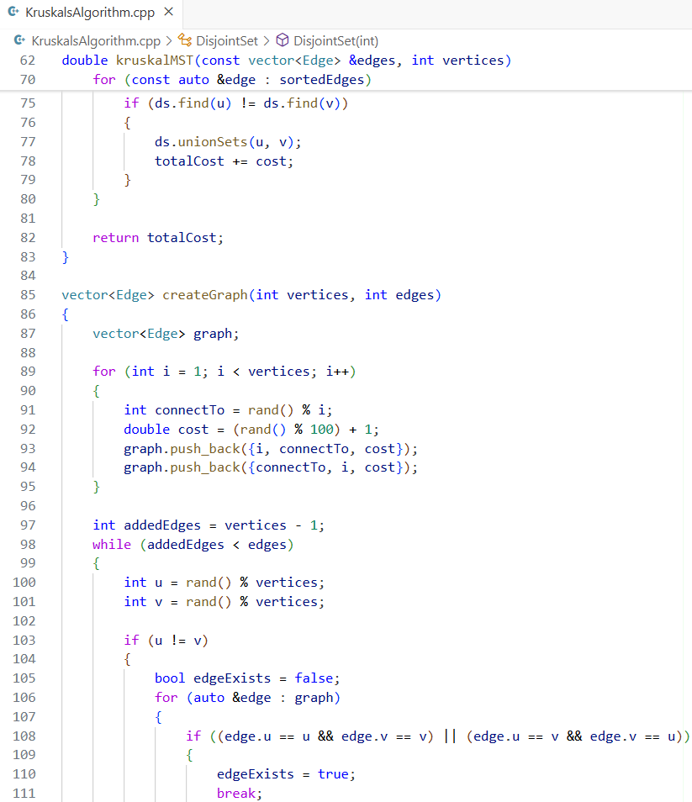
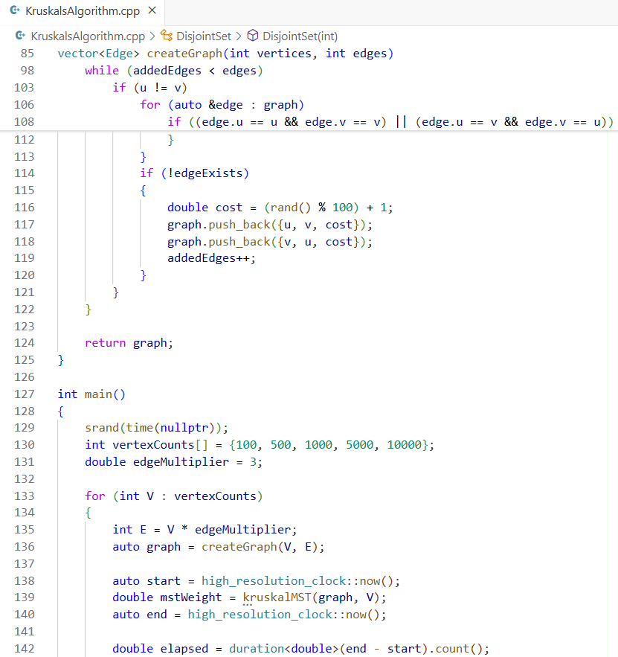
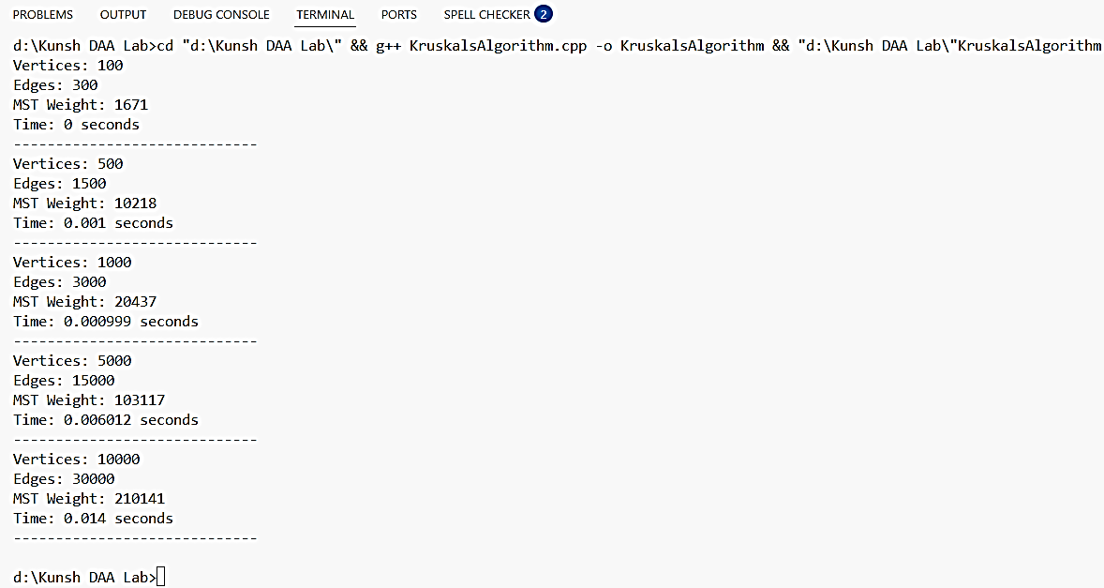
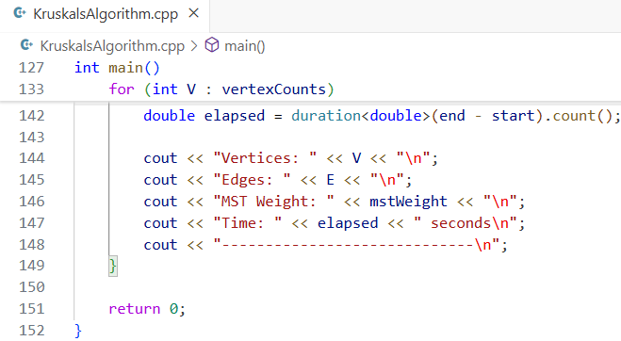
Output:
Input (n) vs Time (t) Table:
Number of Nodes | Time (t) in seconds
100 | 0
500 | 0.001
1000 | 0.000999
5000 | 0.006012
10000 | 0.014

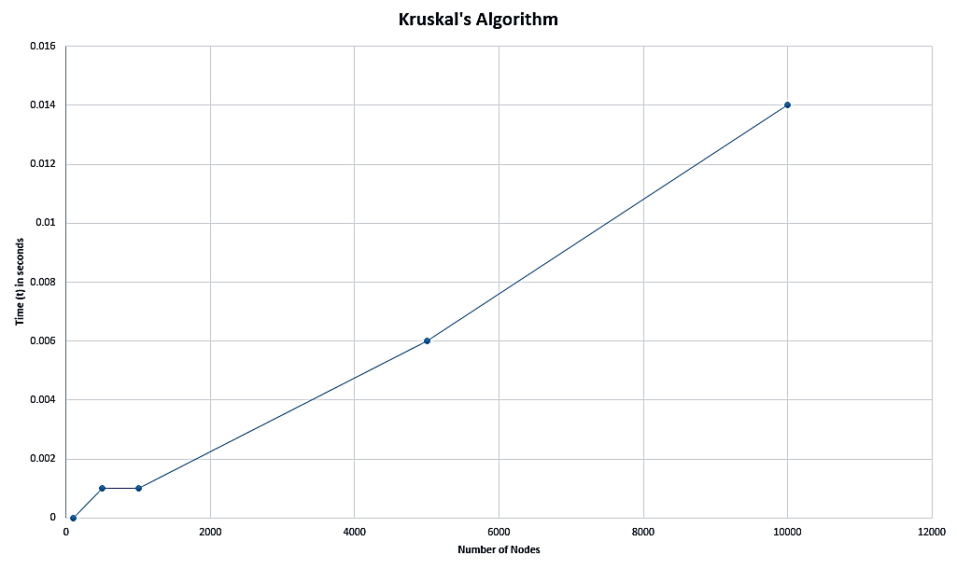
Graph:
Time Complexity:
 | Best | Worst | Average
Kruskal’s Algorithm

Learning Outcome:

EXPERIMENT 9

Problem statement: Write a program to perform Single Source Shortest Path problem using Dijkstra's Algorithm.
Theory:

Algorithm:

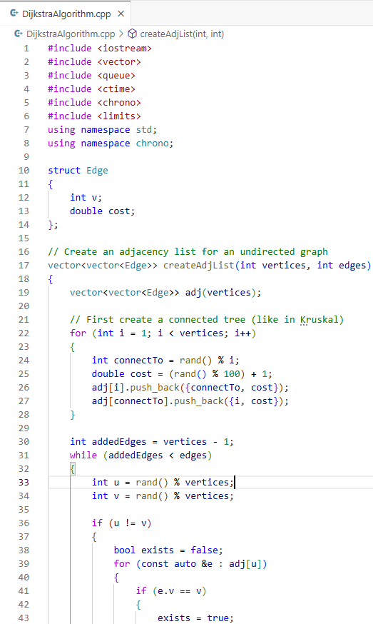
Source Code:
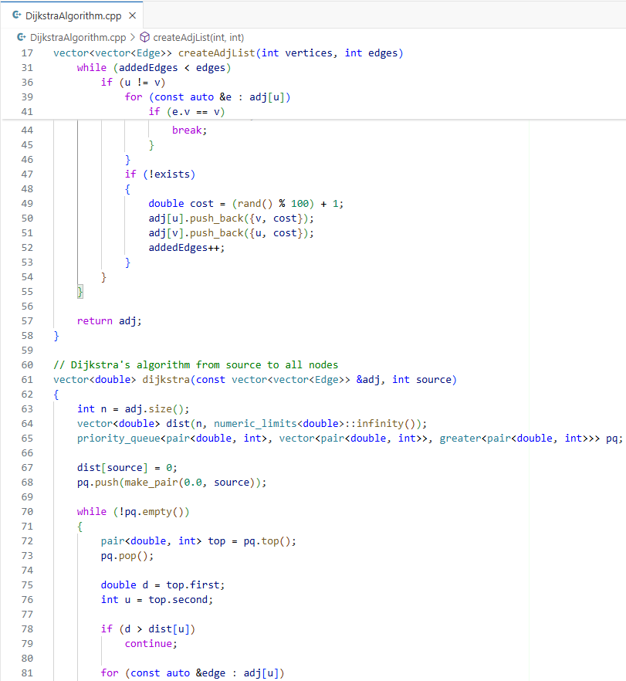
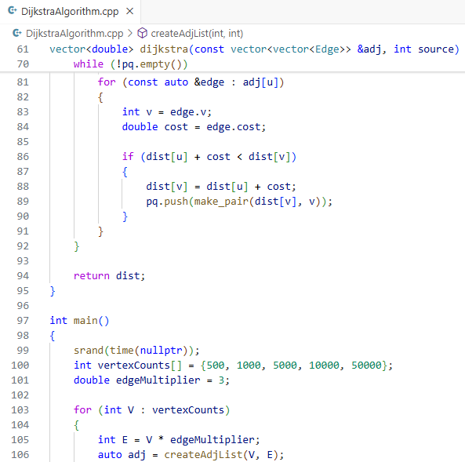

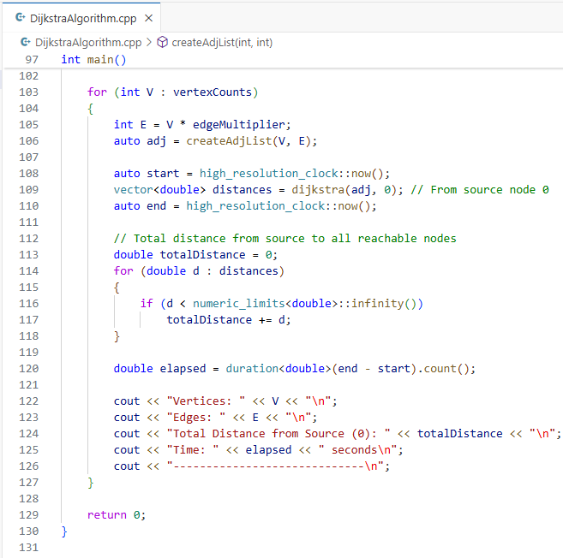
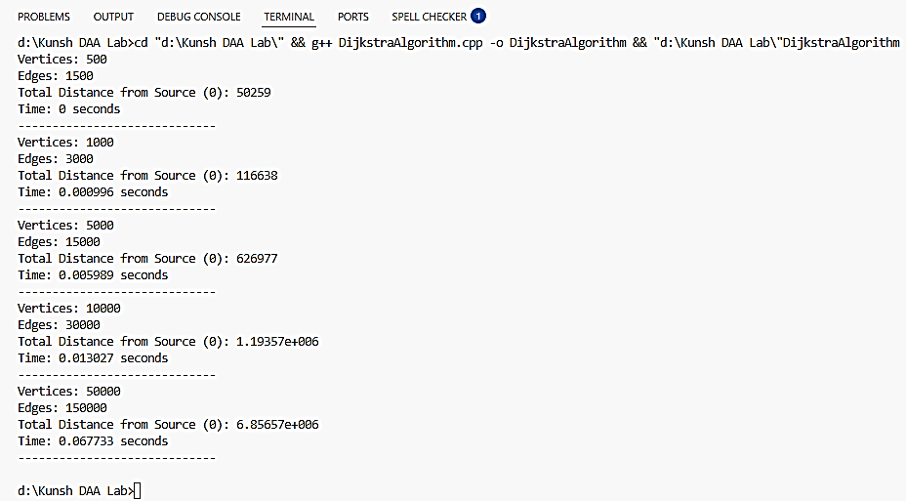
Output:
Input (n) vs Time (t) Table:
Number of Nodes | Time (t) in seconds
500 | 0
1000 | 0.000996
5000 | 0.005989
10000 | 0.013027
50000 | 0.067733
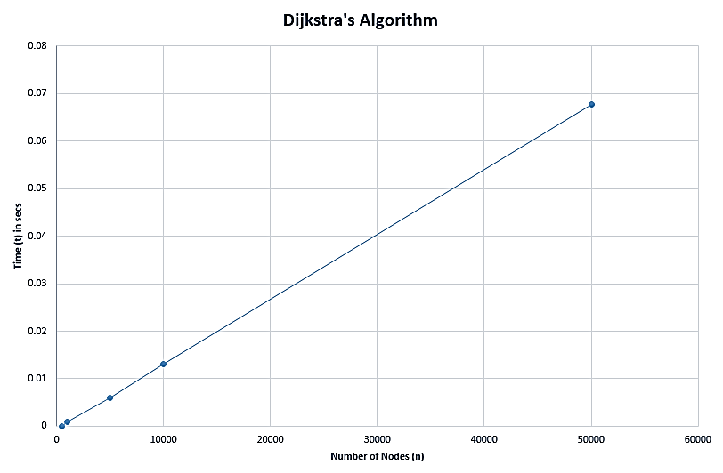
Graph:
Time Complexity:
 | Best | Worst | Average
Dijkstra’s Algorithm

Learning Outcome:

EXPERIMENT 10

Problem statement: Write a program to perform All Pair Shortest Path Algorithm using Floyd Warshall Algorithm.
Theory:

Algorithm:

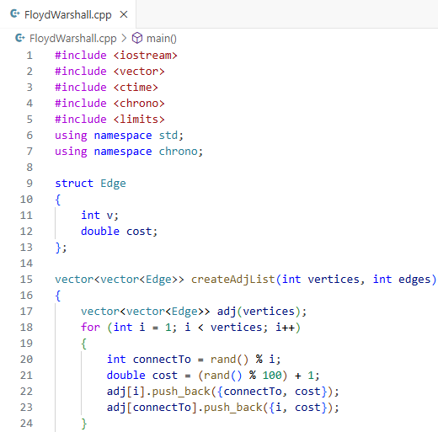
Source Code:
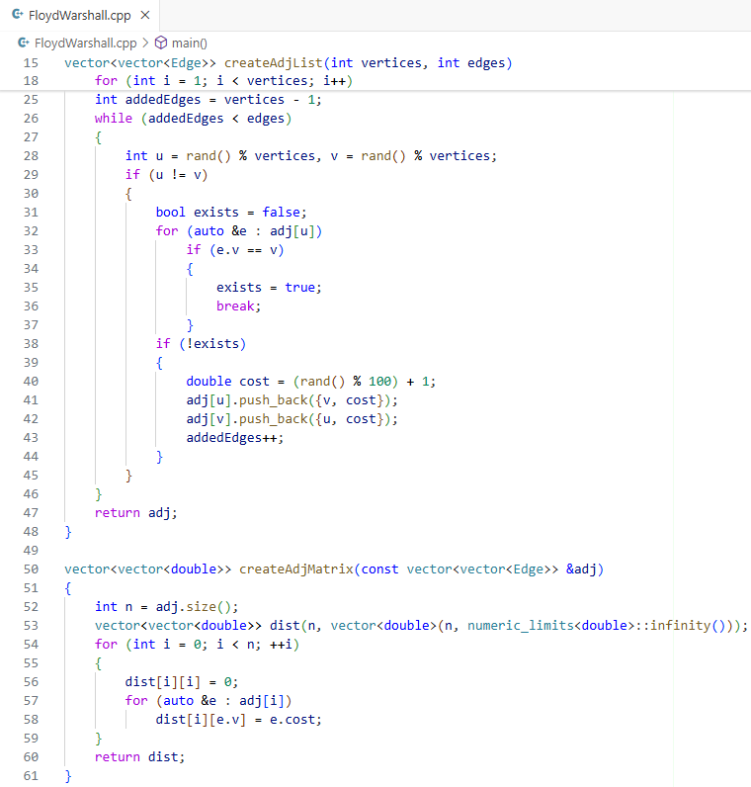
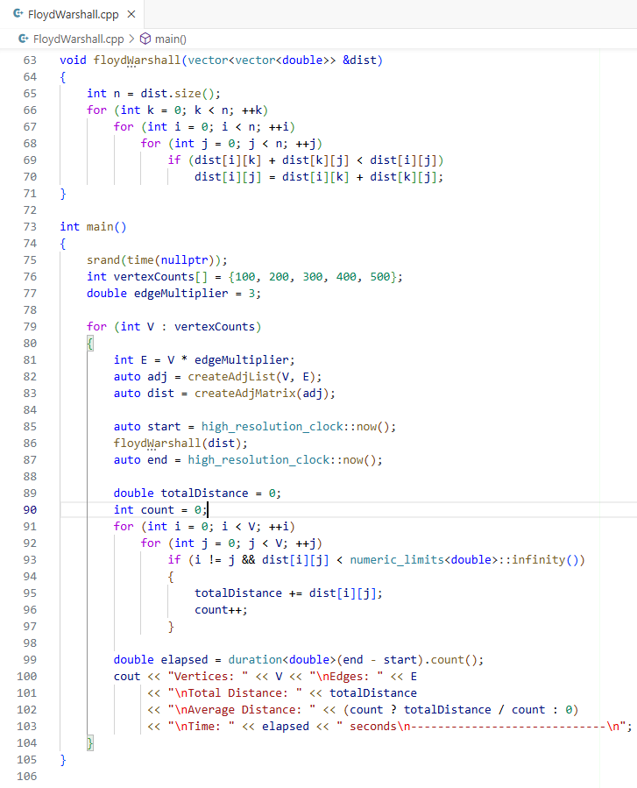
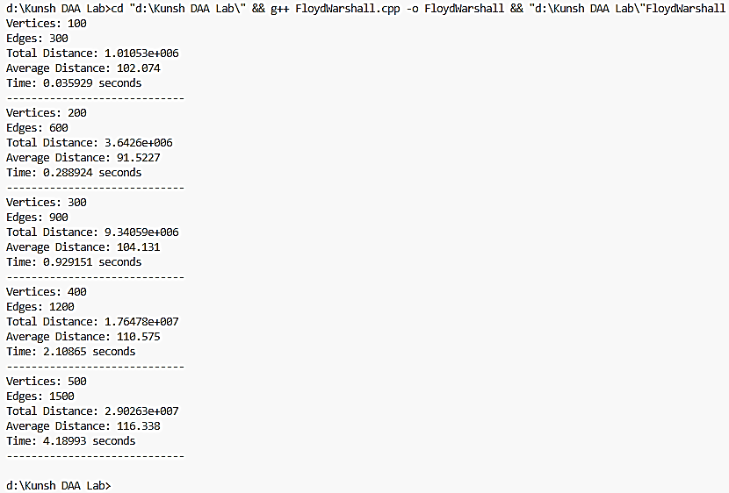
Output:
Input (n) vs Time (t) Table:
Number of Nodes | Time (t) in seconds
100 | 0.035929
200 | 0.288924
300 | 0.929151
400 | 2.10865
500 | 4.18993
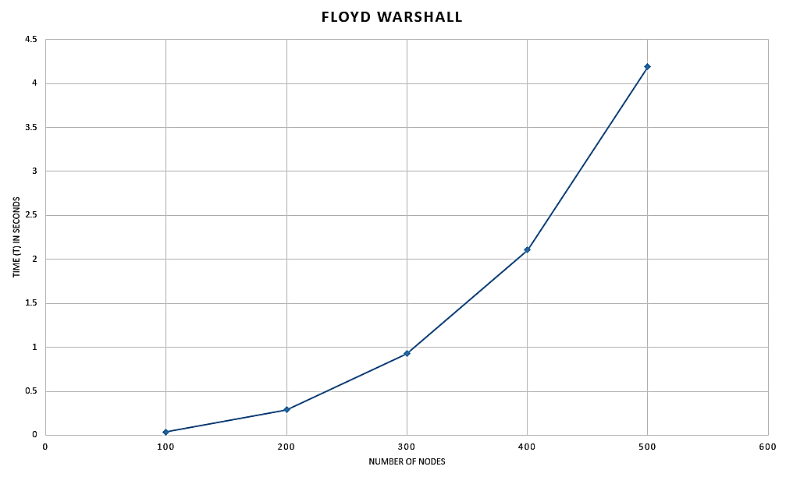
Graph:
Time Complexity:
 | Best | Worst | Average
Floyd Warshall’s Algorithm

Learning Outcome:

EXPERIMENT 11

Problem statement: Write a program to implement N-Queens's Problem using Backtracking Approach.
Theory:

Algorithm:

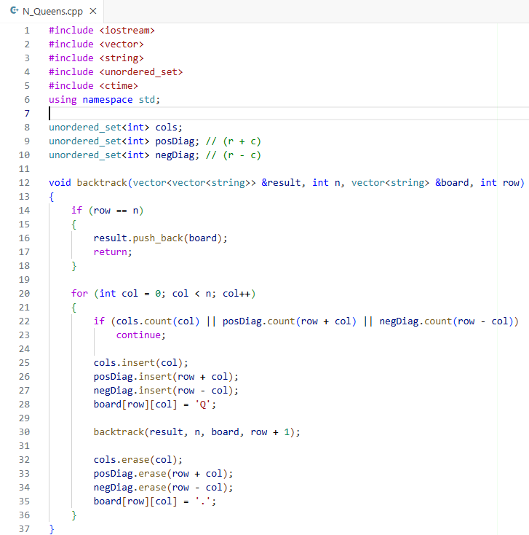
Source Code:
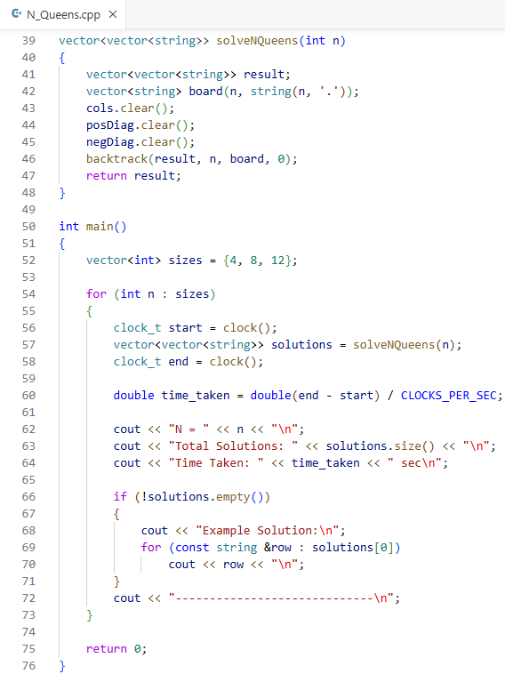
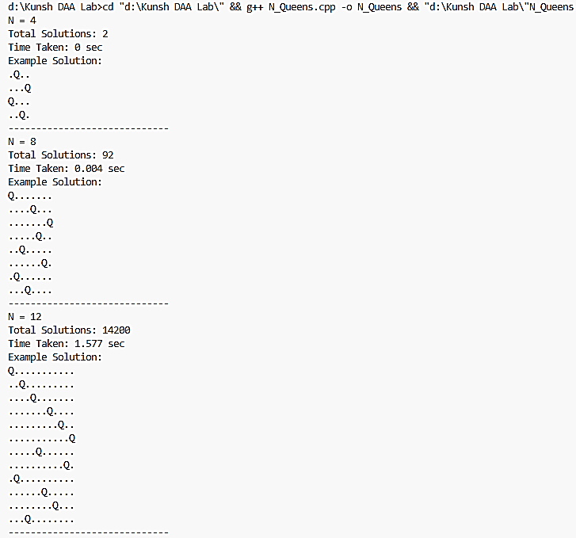
Output:
Input (n) vs Time (t) Table:
Number of Nodes | Time (t) in seconds
4 | 0
8 | 0.004
12 | 1.577
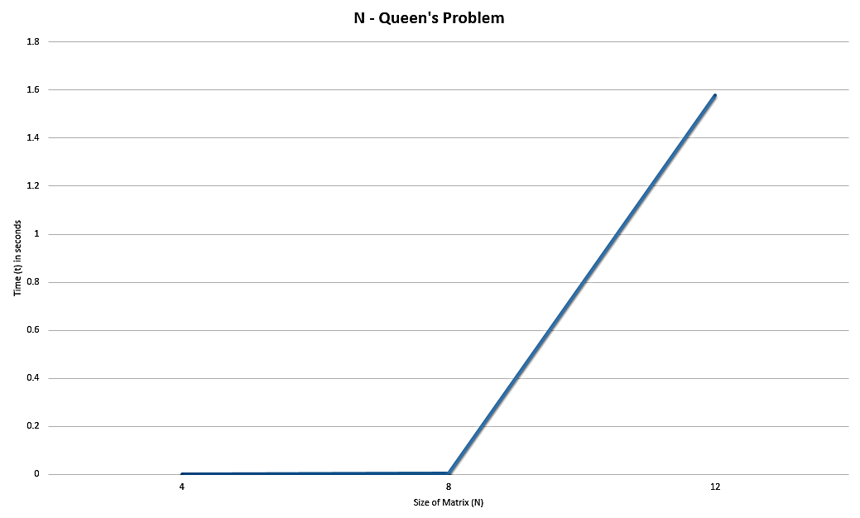
Graph:
Time Complexity:
 | Best | Worst | Average
N-Queen’s Problem

Learning Outcome:

